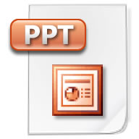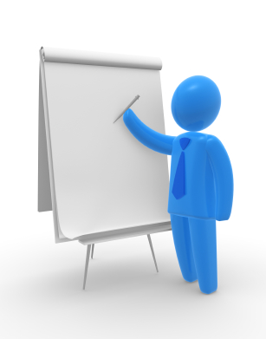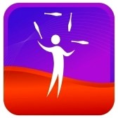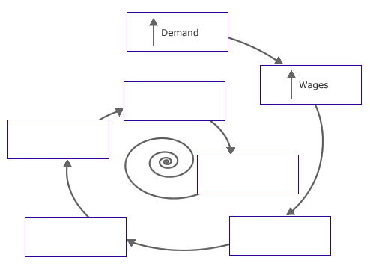
Visual Aids in Speaking
Why use visual aids?
- Make a presentation memorable
- Anchor a message
- Wakes people up—adds variety
- Handouts reduce need for note-taking
- Handouts contribute to speaker credibility
- Can add humor
- Show what you are talking about

Top Tips:
- KISS-Keep It Simple Speaker. Images are powerful. Slides with text aren’t. Limit Text.
- Relevancy--Visual aids should be an integral part of your presentation, not a gimmick
- Practice. Practice. Practice.
- Display when needed (i.e. when done hide, cover or “black” the screen)
- Consider Visibility: Size and style of fonts/writing, size of prop. Stand to the side. Do not obscure the view (typically you want to stand to the audience’s left. Eyes move from left to right like reading)
- Consider transportation. Are your props easily packable and transportable? Will they cause a security challenge? Easily transportable?
- Have a plan B and maybe a plan C for visuals that don’t work (have some “ad-lib” lines ready)
- Use consistent design elements (fonts, graphics, colors)
- Power Point Tip: Use the computer monitor not the screen behind you to see what’s up.
Put your contact information on handouts
Notes: Click or tap here to enter text.

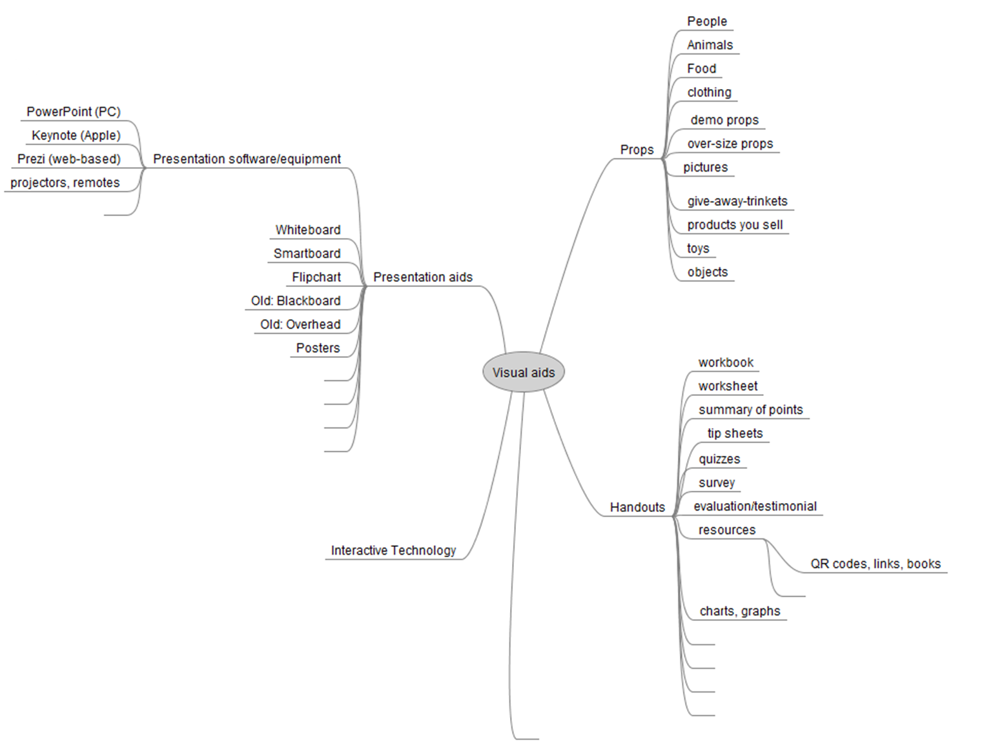
Prop Mind Map

Additional ideas? Click or tap here to enter text.
Examples: Props can create memorable metaphors and add humor to your presentation. Here are a few prop examples from http://www.businessballs.com/visualaids.htm:
paper plane - aim high, explore, strive.
conductors baton - orchestrate, co-ordinate, manage, timing, time-management, turn up the volume or tempo, and anything else related to managing resources and timescales.
bucket of rocks, pebbles and sand - time-management ideas and the 'big rocks in first' story.
beachball - rest, relax, take a break, take your holidays, and ensure your staff do too.
dumbell - exercise, keep fit, healthy body healthy mind.
nodding dog (from the back of a car) - be somebody, make a difference, don't just be a nodding dog, don't surround yourself with 'yes-men', don't be a 'yes-man'.
big clock - time, and time management, scheduling, planning.
globe (inflatables are easy to find) - travel, global markets, widen search for customers, partners, suppliers, sourcing, transport, import, export, international law, currency conversion, exchange rates, time differences, cultures, ethnicity, people - really you can do mostly anything with a globe.
chef's hat - preparation (of anything), mixing, blending (teams, etc), selecting ingredients (identifying and choosing quality components, people, suppliers, methods, etc).
toolbox with tools - toolkit (set of products, tools, methods, materials, documents, etc., each designed for a specific purpose, and related to the other tools in the kit).
WD40 or oil can - the role of a facilitator and the process of facilitation and enablement. The concept of lubricating and liberating, without actually becoming part of the machinery or structure, enabling people and teams to work better - enabling them to do it, not doing it for them. You can also read out the qualities and purposes listed on the oil can, some of which are apt metaphors for the facilitator's role, for example 'frees sticking mechanisms' and 'loosens parts'. (Thanks Paul Carter Organizational Consulting)
lemon - a great visual and tactile prop - better still give everyone a lemon to take home. A lemon can be used to reinforce very many points and themes, including: stimulate as many senses as possible when presenting - a lemon does this - touch, colour, smell, humour, sharpness, simplicity, etc., lemons are great props for train-the-trainer and presentations training, also good for making any point about impact and making things memorable.
Your memorable props:
Click or tap here to enter text.

